DBS301 Lab 4 – Printouts only including the Cover Top and all SELECT statements with OUTPUTS

Due by Monday, February 19th by 2pm

- Display the difference between the Highest pay and Lowest pay in the company.
Name this result Big Difference

select (max(salary) – min(salary)) as “Big Difference”
from employees;

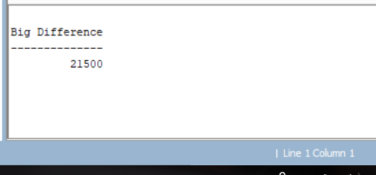
- Display the job title and Highest, Lowest and Average pay per each job. Name these results High, Low and Avg.
Sort the output so that jobs with lowest average salary are shown first.

select job_id, max(salary) "High", min(salary) "Low", avg(salary) "Avg"
from employees
group by job_id
order by avg(salary) desc;

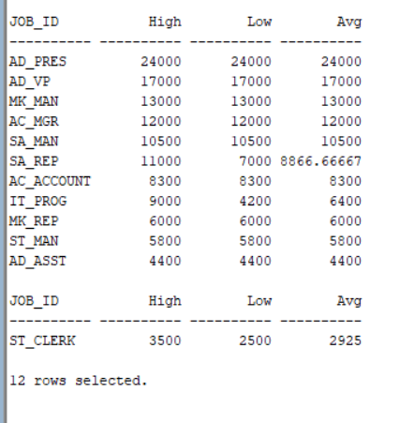

- Display how many people work the same job in the same department. Name these results Dept#, Job_Title and HowMany. Include only jobs that involve more than two persons.
Sort the output so that jobs with the most people involved are shown first.

SELECT department_id "Dep#", job_id "JobTitle", COUNT(*) "HowMany"
FROM employees
GROUP BY job_id, department_id
having count(*) > 1
order by "HowMany" desc
;
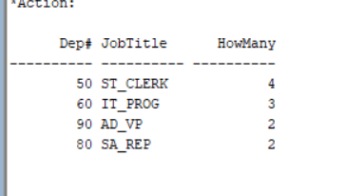

- For each job title display its name and the Total Payroll needed for each job.
Name these results Job_Title and Payroll . Exclude titles AD_VP and SA_REP . Include only jobs that require more than $12,000.
Sort the output so that top paid jobs are shown first.

select job_id, sum(salary) "Total Payroll"
from employees
group by job_id
having job_id != 'AD_VP' and job_id != 'SA_REP' and sum(salary) >= 12000
order by sum(salary) desc;

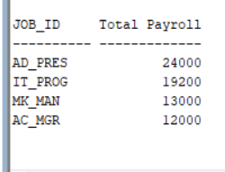

- For each manager number display how many persons he / she supervises. Name these results Mgr# and HowMany . Exclude managers with numbers 100 and 200 and also include only those managers that supervise more than 2 persons.
Sort the output so that manager numbers with the most supervised persons are shown first.

select manager_id "Mgr#", count(employee_id) "HowMany"
from employees
group by manager_id
having manager_id != 100 and manager_id != 200 and count(employee_id) > 2
order by count(employee_id) desc;

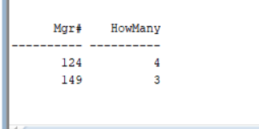

- For each department show the latest and earliest hire date, but exclude departments with Id lower than 60. Include only those departments where the first person was hired in the nineties. Sort the output so that most recent latest hire dates are shown first.

select department_id, min(hire_date) Earliest, max(hire_date) Latest
from employees
group by department_id
having (min(hire_date) < '00-01-01') and (min(hire_date) >= '90-01-01') and department_id > 59
ORDER BY MAX(HIRE_DATE) desc;

